DAILY FINDINGS REPORT
Practical 1 — Basic ICMP Capture (Ping)
Cybersecurity Tool Of The Week
Date | 20 August 2026
Analyst | Emmanuel Aidoo
Practical Note | First Practical of the week
Objective / Scope | Capture and read a live ICMP echo request/reply exchange with tcpdump, as a baseline follow-up to the DNS/ICMP incident case study.
Tools Used | tcpdump, ping
Environment | Ubuntu (lab host), interface eth0

Goals of This Practice
This week's practicals were built around three goals:
- Analyze packets to interpret network communications.
- Use packet sniffing tools to capture and view network communications.
- Describe how network traffic analysis can help to detect, prevent, and respond to security incidents.

1. Objective
Capture and correctly interpret a live ICMP echo request/reply exchange using tcpdump, in order to build baseline packet-reading skills before tackling more complex protocol failures. Specifically: confirm that request and reply packets can be correctly paired using their id and seq fields, and establish what a clean, error-free ICMP exchange looks like at the packet level.

2. Commands / Steps Taken
Two terminals were used: one running the tcpdump capture, the other generating ICMP traffic with ping.

Terminal 1 — Capture
sudo tcpupdump -i eth0 icmp # typo, corrected below
sudo tcpdump -i eth0 icmp
The first attempt had a typo (“tcpupdump”), caught immediately by the shell’s “command not found” error and corrected on the next line — kept in the record as an honest example of real terminal work.

Terminal 2 — Generating traffic
ping -c 10 8.8.8.8
10 echo requests sent to Google's public DNS resolver (8.8.8.8), chosen purely as a reliable, always-on ping target.

3. Evidence
Figure | File / Description | What It Shows
Fig. 1 | icmp-ping-capture-fictionalized.png | Side-by-side terminal capture: tcpdump ICMP output (left) and ping session (right). Hostname and local IP fictionalized.
Figure 1 — Fictionalized terminal capture
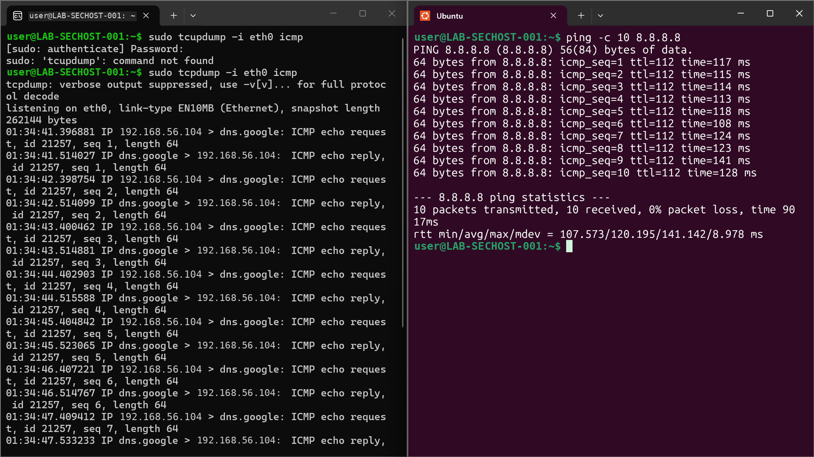

4. Findings / Analysis
Each ICMP echo request line in the tcpdump capture has a matching echo reply roughly 100–140 ms later — consistent with the round-trip times ping itself reported. The two tools describe the same underlying exchange from two different vantage points: ping shows summary statistics, tcpdump shows the raw packets underneath.

Key Observations
- Source: the lab host, sending each echo request. Destination: dns.google (8.8.8.8), used purely as a reliable ping target, not itself under investigation.
- id 21257 stayed constant across all 10 packets, identifying every ping in this run as belonging to the same ping process/session.
- seq 1 through seq 10 incremented by exactly 1 each packet, confirming every request received a matching reply, in order, with none dropped or out of sequence.
- Result: 10/10 packets transmitted and received, 0% packet loss — a clean, healthy ICMP exchange with no errors, retries, or unreachable messages.

5. Conclusion
The capture confirms a fully healthy ICMP path between the lab host and 8.8.8.8: every request was answered, in sequence, within a consistent latency range (rtt min/avg/max/mdev = 107.573/120.195/141.142/8.978 ms). This session's primary value is as a baseline — a reference point for what normal, error-free ICMP traffic looks like in tcpdump.
- Verified that tcpdump's packet-level view and ping's own summary statistics describe identical underlying traffic, useful for cross-checking evidence from two tools in a report.

6. IP Header Fundamentals — Week 1 Learning Notes
Notes from the first week of tool analysis, covering how the Internet Protocol (IP) structures packet headers to guide delivery across a network.
- IP operates at the internet layer of the TCP/IP model, ensuring packets reach their destination using information carried in the packet header, such as source and destination IP addresses.
- IP headers carry the essential fields that guide packet delivery. IPv4 and IPv6 use different header formats, but serve the same underlying purpose.

Key IPv4 Header Fields
Figure 2 — The IPv4 header and its 13 fields
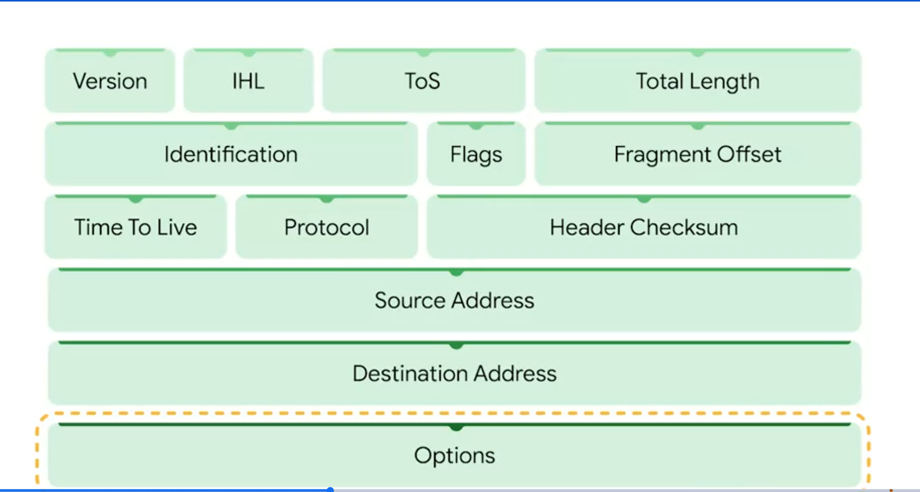
- Version — indicates the IP version in use (IPv4 or IPv6), similar to how a mail class (priority, express) marks how an envelope should be handled.
- IHL (Internet Header Length) — specifies how long the header itself is, including any Options.
- ToS (Type of Service) — marks a packet for special handling or priority, similar to marking physical mail “fragile” or “priority.”
- Total Length — the size of the entire packet, header plus data.
- Identification, Flags, and Fragment Offset — work together to manage fragmentation and reassembly (detailed below).
- TTL (Time to Live) — limits how long a packet may circulate, preventing endless routing loops (detailed below).
- Protocol — identifies which transport protocol the data portion uses, e.g. TCP.
- Header Checksum — verifies the header itself hasn't been corrupted in transit.
- Source Address / Destination Address — the sender's and receiver's IP addresses.
- Options — optional, used mainly for diagnostics/troubleshooting; the packet's actual data follows the header, much like the contents inside an envelope.

TTL — Time to Live
TTL determines how long a packet may exist on the network before being discarded. Its purpose is to prevent a packet from circulating endlessly if it gets caught in a routing loop. Each router that forwards the packet decrements the TTL value by one; once TTL reaches zero, the packet is dropped. This keeps network traffic manageable and prevents congestion from packets that can never reach their destination.
Q: Without TTL, what happens to packets?
A: Confirmed — without a TTL field, a packet caught in a routing loop would never be discarded. It would circulate between routers indefinitely, continuously consuming bandwidth and router processing capacity, contributing to network congestion. TTL exists specifically to guarantee that even a misrouted packet is eventually dropped.

Fragmentation Fields — Identification, Flags & Fragment Offset
The Identification field uniquely identifies each packet sent from a source, and is the key to fragmentation and reassembly: when a large packet is broken into smaller fragments for transmission, every fragment shares the same Identification value so the receiving device can correctly reassemble them into the original packet.
The Flags field controls and indicates fragmentation. It carries bits specifying whether the packet is allowed to be fragmented at all (the Don't Fragment flag), and whether a fragment has more fragments following it (the More Fragments flag).

Analyzing Fragmentation
To determine whether fragmentation occurred in a capture, and how to reassemble it, focus on three fields together:
- Identification — identifies all fragments belonging to the same original packet.
- Flags — indicates whether the packet is fragmented, and whether more fragments follow.
- Fragment Offset — specifies where a given fragment's data belongs within the original packet.
Examining these three fields together reveals whether fragmentation occurred, how many fragments exist, and the correct order to reassemble them in.
NB: The TCP/IP model is the overall framework used to visualize how data is addressed, routed, and delivered across a network — IP headers are one piece of that larger model.

7. Wireshark vs tcpdump
Both are network protocol analyzers used to capture and inspect traffic, but they differ in interface and typical use case.
Figure 3 — Wireshark / tcpdump comparison (Venn diagram template)
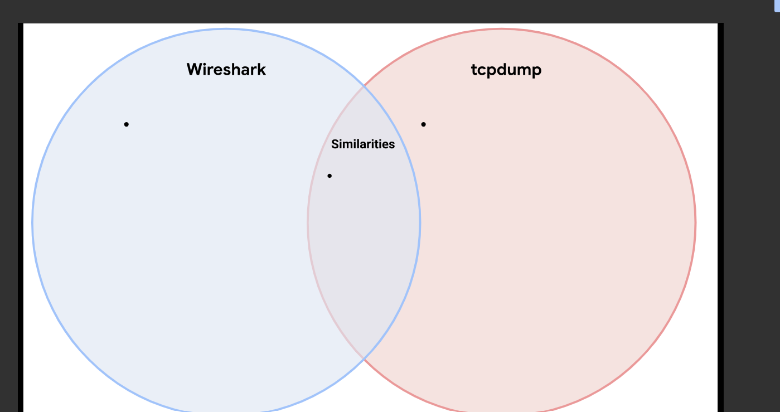
Wireshark | Similarities | tcpdump
Graphical interface (GUI) | Both read/write .pcap-format captures | Command-line only (CLI)
Easier visual inspection of packets | Both used by analysts to investigate traffic | Lightweight and scriptable
“Follow stream” reconstructs full conversations | Both support filtering to isolate relevant packets | Well-suited to headless/remote servers over SSH
Richer built-in protocol decoding, shown visually | Both are free and open-source | Faster for a quick capture with no GUI needed

8. Glossary of Acronyms
Acronyms used in this week's notes:
Acronym | Meaning | Note
IP | Internet Protocol | The addressing/routing standard packets use to reach their destination.
IPv4 | Internet Protocol version 4 | The most widely used IP version; uses 32-bit addresses.
IPv6 | Internet Protocol version 6 | Newer IP version with a much larger address space.
IHL | Internet Header Length | IPv4 field stating how long the header itself is.
ToS | Type of Service | IPv4 field indicating how a packet should be prioritized.
TTL | Time to Live | Field limiting how long/how many hops a packet may travel before being discarded.
TCP | Transmission Control Protocol | A reliable, connection-oriented transport protocol.
TCP/IP | Transmission Control Protocol / Internet Protocol | The overall framework describing how data is addressed, routed, and delivered across a network.
NB | Nota Bene (Latin: “note well”) | Used to flag an important side note.

9. References & Resources
Links referenced while building this week's notes:

Official Documentation
- tcpdump manual page: http://tcpdump.org/manpages/tcpdump.1.html
- tcpdump.org — documentation index: https://www.tcpdump.org/index.html#documentation

Course Materials
- Week 1 slide deck: https://docs.google.com/presentation/d/1BbykpkPTPk79tzn7RUNBz0BJH_9BEFtqkpiUi9vo1Y4/edit?slide=id.p#slide=id.p

10. Tcpdump Fundamentals — Course Notes
Foundational notes on using tcpdump to capture and analyze network traffic from the command line.

Tcpdump Overview
- Pre-installed on many Linux systems, and able to capture a wide range of protocols, including TCP, IP, and ICMP.
- Operates entirely via the command line, with no graphical interface — this is what allows fast, scriptable filtering of traffic by IP address, protocol, or port.

Using Tcpdump Commands
- Example: sudo tcpdump -i any -v -c 1 captures a single packet on any network interface, with verbose output.
- sudo — grants the elevated permissions tcpdump needs to capture raw traffic.
- -i — specifies which network interface to capture on.
- -v — enables detailed (verbose) packet information in the output.
- -c — limits how many packets are captured before stopping.

Interpreting Tcpdump Output
- Every line of output includes a timestamp, the IP version, and detailed IP-layer fields such as Type of Service (ToS), Time to Live (TTL), and fragmentation information.
- Output shows source and destination IP addresses with port numbers, checksum validation, and TCP flags that indicate packet behavior, such as PSH (push) or ACK (acknowledgment).
This foundational knowledge supports network monitoring and incident investigation by revealing detailed, packet-level data — exactly the skill practiced hands-on in Practicals 1 and 2 above.

11. How the Goals Were Covered
Mapping each goal above to where it was actually put into practice across this week's work:

Goal 1 — Analyze packets to interpret network communications
- Practical 1 (ICMP): reading paired ICMP echo request/reply lines and matching them by id and seq (Section 4, Practical 1).
- Practical 2 (DNS): tracing a dig lookup through its matching tcpdump query/response pair, including diagnosing why a capture showed no packets by cross-referencing dig's own SERVER: line (Section 4, Practical 2).
- IP Header Fundamentals: walking through all 13 IPv4 header fields individually and what each one tells an analyst (Section 6).

Goal 2 — Use packet sniffing tools to capture and view network communications
- Hands-on tool use: used tcpdump directly, live, in both practicals — building and correcting real capture commands (typo corrections included) rather than only reading about them.
- Tool comparison: compared tcpdump (CLI) against Wireshark (GUI) side by side — what each is best suited for, and where their capabilities overlap (Section 7).
- Interface selection: captured on eth0, then any, and read back a WSL2 loopback-routed DNS exchange — practical experience choosing the right interface for a given capture.

Goal 3 — Describe how network traffic analysis can help detect, prevent, and respond to security incidents
- Baselining: both practicals this week established what healthy, error-free ICMP and DNS traffic looks like — the baseline an analyst needs before abnormal traffic (like the ICMP “port unreachable” errors in the earlier incident case study) becomes recognizable.
- Incident-style reasoning: the DNS capture troubleshooting (Practical 2) is a direct example of using traffic analysis to respond to an unexpected result — cross-referencing tool output against ip a to diagnose, rather than guessing.
- Detection relevance: TTL, fragmentation fields, and header integrity (Section 6) are exactly the fields an analyst inspects when investigating routing anomalies, spoofing, or fragmentation-based evasion techniques.

